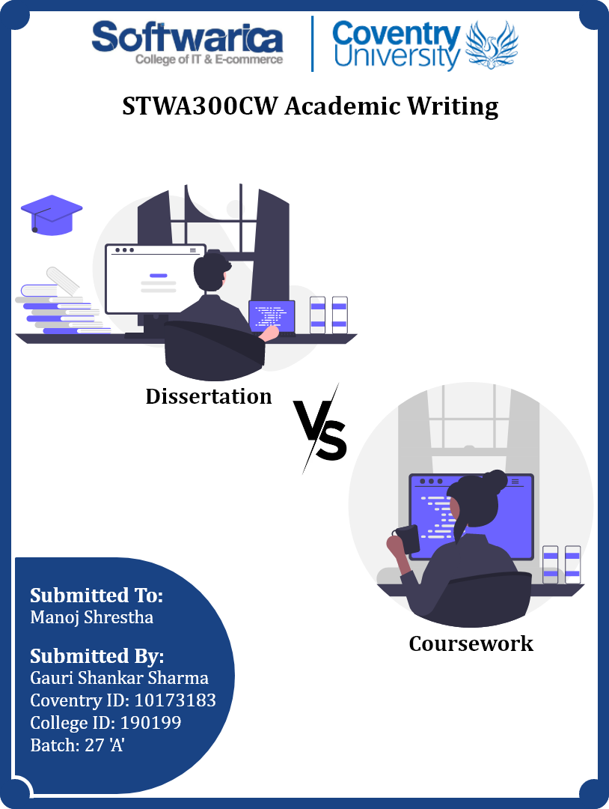

**Keywords**

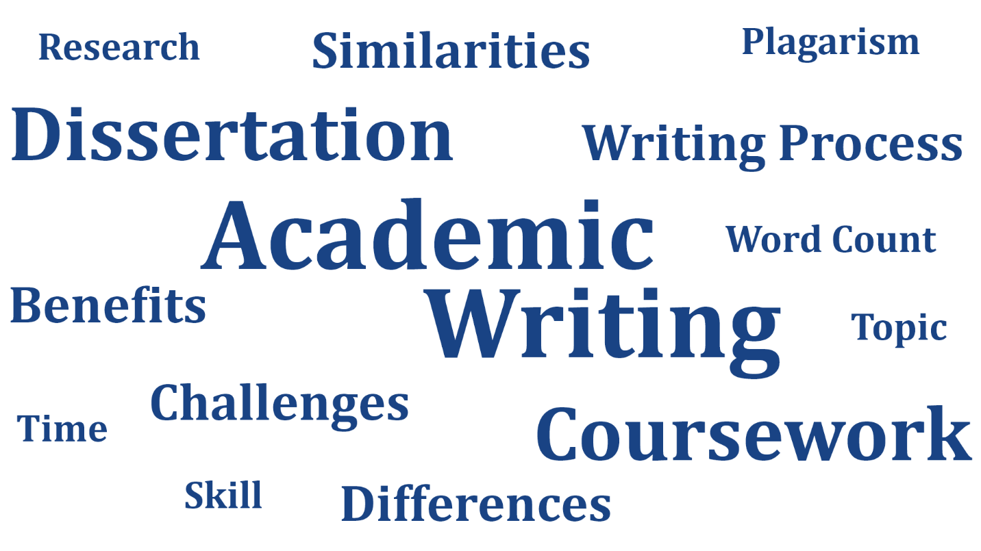

Figure 1: Keywords of dissertation vs coursework writing

**Table of Contents**

**Academic Writing** 1

**Dissertation and Coursework** 2

**Similarities and Differences** 2

**Writing Processes** 4

**Benefits and Challenges** 6

**Conclusion** 7

**References** 8

**Table of Figures**

Figure 1: Keywords of dissertation vs coursework writing 2

Figure 2: Academic and Personal Writing 1

Figure 3: Similar and differentiating terms between dissertation and coursework 2

Figure 4: Dissertation and coursework writing process 4

Figure 5: Benefits and challenges of dissertation and coursework writing 6

# **Academic Writing**

Academic writing interconnects information, thoughts, and seek to the wider academic community. It is not complicated, or long-winded. It is also not journalistic, literary, or marketing text. It is formal and unbiased, clear, precise, focused, well structured, well-sourced, and consistent (Scribbr, 2022). It’s rules and regulations differ it from personal writing. Its main focus is to make the readers understand what they are reading with the proper and succinct language.

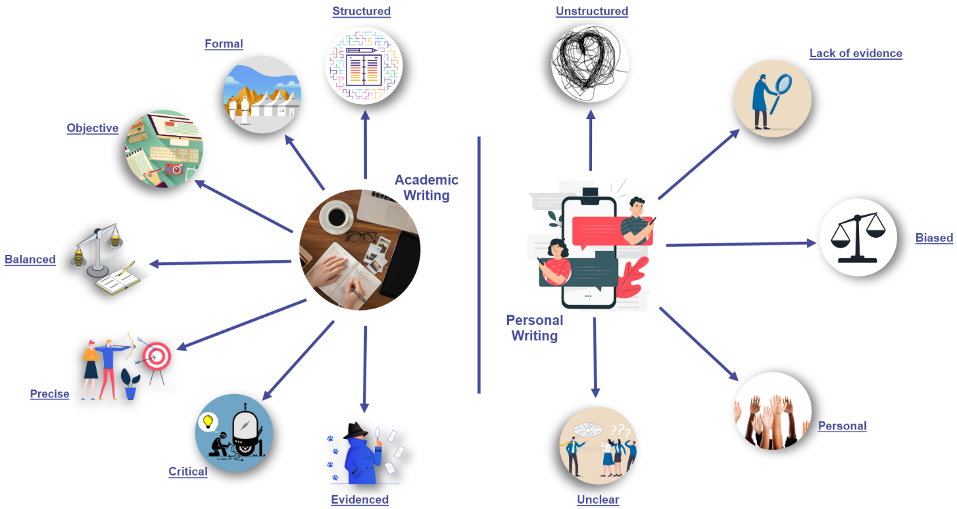

Figure 2: Academic and Personal Writing

Academic writing has a clear structure that provides sense, Opinions and arguments are supported by evidence (facts, reasons, examples, statistics, citations) whereas personal writing lacks these things. In the same way, Information is analyzed and evaluated, languages are clear, and precise too. On the other hand, personal writing might not be clear and informative. Academic writing studies issues from different sides and excludes bias. However, personal writings are biased often. In academic writing, information is based on the arguments and information, but not on the writer. Similarly, Passive and impersonal structures are used but do not use complicated vocabulary and long sentences (EAPFoundation.com, 2021). Conversely, personal writing includes active voices and short-form words, and the words might be complicated too.

# **Dissertation and Coursework**

A dissertation is research done on a specific topic over a long period to achieve some solutions to a problem or to discover something new and useful. It can be the most important, longest, and most difficult, assignment done by students at university (Collier, 2022). On the other hand, coursework is the practical or written work given to the students while studying a course that has to be completed within a given period.

## **Similarities and Differences**

The same language, style, tone, grammar, and document formats are used in both coursework and dissertation. Similarly, both increase students’ capabilities of thinking critically, researching, creativity, innovation, communication, sharing ideas, and time management. Both writings have to be completed within a certain time otherwise they might fail. Research for answering questions, learning new things, and clearing confusion is needed. However, the time and amount of research might vary but without research, both cannot be completed. Most of the students go through the internet sources like online libraries, encyclopedias, and websites because it saves time. However, there is not much difference in what kind of tools and technology have to be used in coursework or dissertation, for example, documentation with MS word, making infographics with Adobe XD. Both require guidance from the lecturer at some level. Similarly, they can review it, and get feedback.

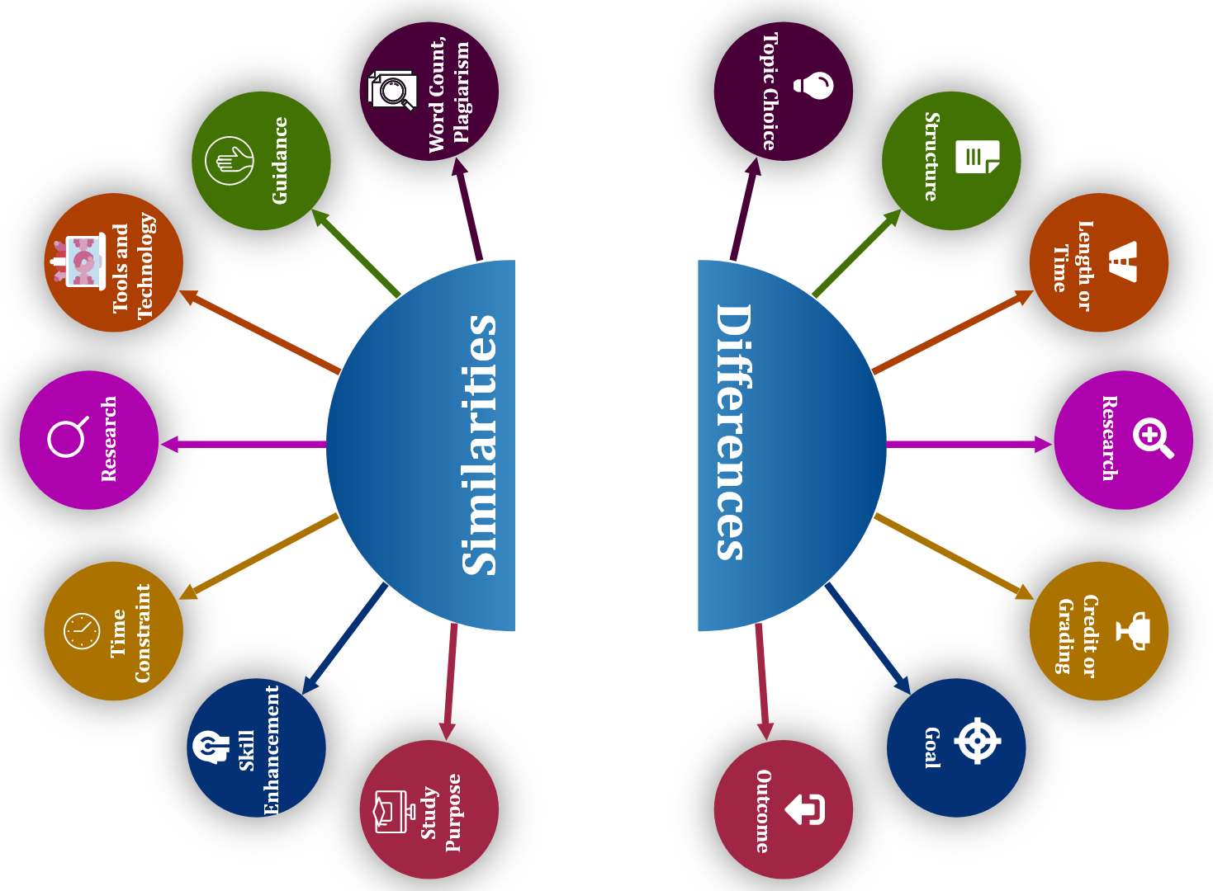

Figure 3: Similar and differentiating terms between dissertation and coursework

This will improve their writing. Both writings have word count limits as well as plagiarism checking, otherwise, students might score low in their final grade even though the contents are very good if the word count is not under the limitation, or the document gets high plagiarism. (Schoolworkspro, 2022).

In dissertation, students pick a topic of their interest and the research questions have to be raised by themselves whereas the topic is provided by the lecturer most of the time in coursework. The coursework structure is already defined in the course whereas the dissertation does not have a particular structure. In the same way, dissertation word count is greater than the coursework. The writing period of the dissertation is very long and could take more than one semester but the coursework is finished before the semester is completed. A little research can be enough for a coursework to be finished whereas a dissertation requires a month of preparation and lots of research. A dissertation carries more credit than coursework. The coursework has already predefined guidelines and marking schemas but a dissertation does not have fixed marking schemas or guidelines. Students are free to research anything related to the topic and can add an extra element to the writing. A dissertation will give a university degree whereas coursework is done to complete a single course. A coursework outcome is already defined but the dissertation outcome might be different from the student’s expectation or might be more valuable but it is unclear at first (Schoolworkspro, 2022).

## **Writing Processes**

A dissertation is a complex task. Before diving into it, students should have a clear understanding of the dissertation and how it is done. Similarly, students have to brainstorm for a clear, unique, and important research topic. The topic should clear the student research plan, should be based on a question that is never been asked before and the question should create value. Then, a research proposal is submitted to the university to show that the research topic is worthy enough. Students can start writing the dissertation and they won’t have a hard time starting the introduction, literature review, and methodology if they have crafted a high-quality proposal. Similarly, students have to introduce the dissertation with a brief background, problem statement, research questions, and significance of the research.

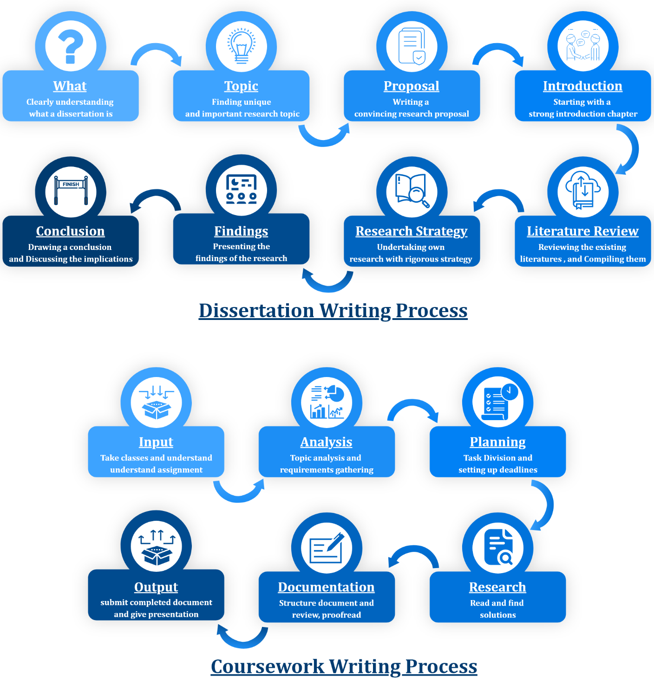

Figure 4: Dissertation and coursework writing process

Then, students write up a literature review chapter that synthesis the existing research, highlights a research gap, and inform the methodology. Moreover, students also need to conduct their research to answer research topic unique questions. Research strategy has to be developed by themselves. The collected data should be executed and analyzed and then findings in the results chapter. At last, students complete the dissertation with a conclusion that highlights the key findings and elaborates the implications (Blair, 2016) (Jansen, 2020).

The coursework writing process is a bit easier compared to the dissertation because students can get help from the lecturer frequently, can follow the predefined marking schemas, and can easily find the solution. However, they have to attend the classes given by the lecturer. They need to understand the assignment brief or can discuss this with their lecturer to clear their confusion about the assignment. Then, they have to choose a topic if the topic is not given. Before writing the coursework, it is better to plan it. Dividing it into multiple tasks and setting up a deadline for each task will be beneficial for managing time, and completing it before the submission deadline. Furthermore, students need to brainstorm for the right solution, do some research like find answers, and solutions, read books, journals, and websites, and gather all the requirements. Moreover, they have to write the document in a structure and be careful about the word count and plagiarism. At last, they need to review, proofread, and edit their document, and get feedback from the lecturer. After then, the completed assignment will be submitted. There will be also presentation slides if needed (Admin, 2017) (Vainer, 2019).

## **Benefits and Challenges**

Students can gain knowledge and develop lots of skills by writing dissertation or coursework. They will be better at reading, understanding, and writing. In the same way, they will critically think about a problem to find a solution. They will enhance problem-solving, communication, creativity, innovation, and research skill. The dissertation will increase researching, and analyzing skills more than coursework. Students will be better at managing time and working on the deadline. Likewise, they will get the confidence to take on the challenges when they finish their work. Good coursework or dissertation will provide a better grade that will give students satisfaction, and good feelings, and keep their interest high (Achievers, 2021) (Wanic, 2015). Students will complete a single module in a coursework. But a dissertation will give the students a university degree. A dissertation will be very helpful for a better career and give long-term achievement. Coursework will be also helpful to get success in a particular field like getting a job.

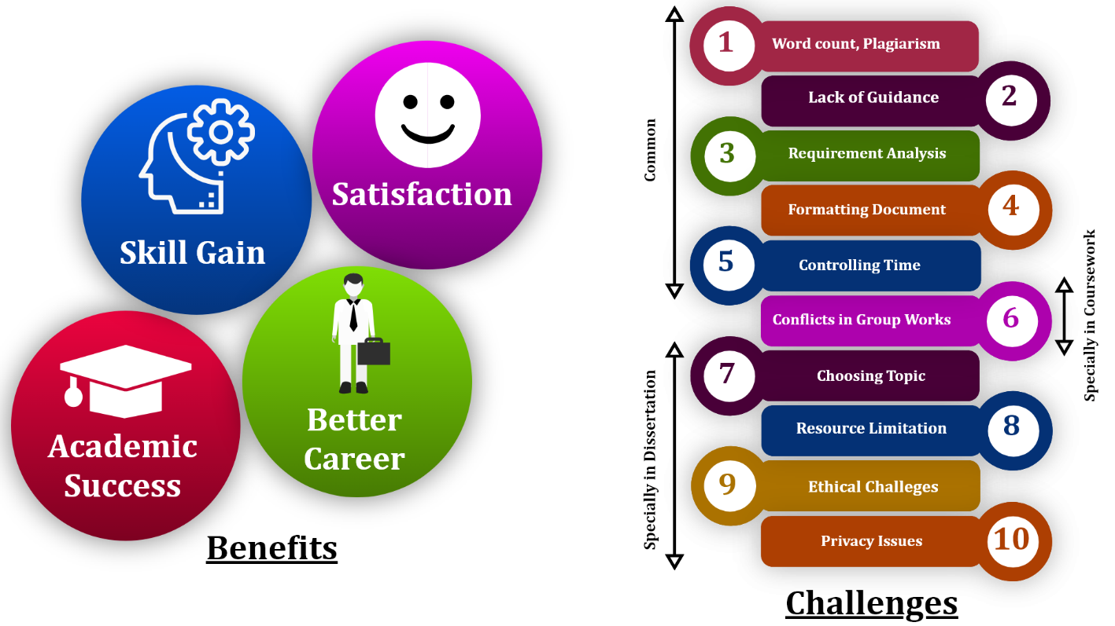

Figure 5: Benefits and challenges of dissertation and coursework writing

Writing a dissertation is harder work than writing coursework. Students have to write both coursework and dissertation under the limitation of word count and should be free of plagiarism. However, plagiarism is found in most students’ writing. Most of the students cannot manage their time and they complete only some part of the coursework or dissertation even though the deadline is near. Similarly, getting frequent helps from the lecturer might not be possible because the lecturer might not be available in some cases (Writing, 2018). Documentation is another challenge. The student’s document might not be in the correct format or structure. The language or grammar might not be satisfying for the lecturer. In most group projects, there is a high risk of disagreement, so strong collaboration is essential. Choosing a clear, unique, and valuable topic is the first challenge in dissertation. Even though the topic is approved by the university, students might have a really hard time finding enough resources like books, journals, and research papers to support the research topic. In the same way, wrapping the researched resources into single new information is not easy too (Burgess, 2022).

# **Conclusion**

Academic and personal writing are not same. Even though coursework and dissertation are academic writing, they don’t match in some manners. A dissertation requires hard work and takes longer time than coursework to be finished. A dissertation gives long-term achievement. Coursework questions and outcomes are predefined whereas it is unclear and needs to be researched a lot more in the dissertation. Both coursework and dissertation are completed to get success in the educational field. Similarly, writing coursework and dissertation will give many challenges to the students and both will enhance students’ skills. A dissertation is harder work than coursework. But completing both perfectly leads to great achievement and provides better career opportunities.

# **References**

Achievers, A., 2021. *Medium.* [Online]   
Available at: https://assignmentachievers.medium.com/benefits-of-using-coursework-writing-service-89278ddc7a91  
[Accessed 03 May 2022].

Admin, 2017. *Planning Tank.* [Online]   
Available at: https://planningtank.com/academic-writing/coursework  
[Accessed 26 April 2022].

Admin, 2017. *Planning Tank.* [Online]   
Available at: https://planningtank.com/academic-writing/write-coursework-tips-steps  
[Accessed 01 May 2022].

Blair, L., 2016. *Writing a Graduate Thesis or Dissertation.* Rotterdam: Sense Publishers.

Burgess, E., 2022. *Tutorhouse.* [Online]   
Available at: https://tutorhouse.co.uk/blog/top-challenges-of-writing-a-dissertation-and-how-to-overcome-them  
[Accessed 06 May 2022].

Carini, A., 2022. *Berkeley University of California.* [Online]   
Available at: https://slc.berkeley.edu/writing-worksheets-and-other-writing-resources/nine-basic-ways-improve-your-style-academic-writing  
[Accessed 25 April 2022].

Collier, S., 2022. *Top Universities.* [Online]   
Available at: https://www.topuniversities.com/blog/what-dissertation  
[Accessed 26 April 2022].

EAPFoundation.com, 2021. *Youtube.* [Online]   
Available at: https://www.youtube.com/watch?v=Cq4J8bPBcck  
[Accessed 23 April 2022].

Hull, C., 2022. *Canvas.hull.ac.uk.* [Online]   
Available at: https://canvas.hull.ac.uk/courses/368/pages/what-is-a-dissertation  
[Accessed 27 April 2022].

Jansen, D., 2020. *Gradcoach.* [Online]   
Available at: https://gradcoach.com/how-to-write-a-dissertation-or-thesis-101/  
[Accessed 29 April 2022].

PaperWritingPro, 2019. *PaperWritingPro.* [Online]   
Available at: https://www.paperwritingpro.com/what-is-coursework/  
[Accessed 26 April 2022].

Schoolworkspro, 2022. *Schoolworkspro.* [Online]   
Available at: https://schoolworkspro.com/modules/academic-writing-3/writing-samples  
[Accessed 28 April 2022].

Scribbr, 2022. *Scribbr.* [Online]   
Available at: https://www.scribbr.com/category/academic-writing/  
[Accessed 21 April 2022].

University, L. H. o. S., 2021. *The University of Sydney.* [Online]   
Available at: https://www.sydney.edu.au/students/writing/types-of-academic-writing.html#:~:text=The%20four%20main%20types%20of,specific%20language%20features%20and%20purposes.  
[Accessed 24 April 2022].

Vainer, J., 2019. *The Antelope Valley Time.* [Online]   
Available at: https://theavtimes.com/2019/11/09/7-steps-to-writing-the-perfect-coursework/  
[Accessed 01 May 2022].

Wanic, E., 2015. *Career Camel.* [Online]   
Available at: http://www.careercamel.com/benefits-writing-dissertation/  
[Accessed 03 May 2022].

Writing, C. S., 2018. *IsEssay.* [Online]   
Available at: https://isessay.com/blog/how-to-solve-the-biggest-problem-with-coursework-writing-service/  
[Accessed 05 May 2022].